**Name: Jacob Knaup**

**ID: 1208852537**

**Semester: Fall 2017**

***My mentor approves the FURI office publishing excerpts from my summary to promote my research experience on the FURI web site: YES***

***Abstract***—**Laminate devices have the potential to lower the cost and complexity of robots. Taking advantage of laminate materials’ flexibility, a high-performance jumping platform is developed. The platform is designed by first gaining an understanding of the system using a simplified single-mass model. Then, a more robust multibody computer simulation, incorporating variable lengths and flexibilities, is developed. The leg design parameters are chosen to optimize jump height, and multiple physical platforms are built utilizing laminate construction. The platforms’ jumping abilities are then tested and analyzed in comparison with the simulation results.**

**Description of Method**

Design Process

Starting with the goal of developing a high-performance platform for legged locomotion utilizing laminate construction techniques, a platform suitable for dynamic hopping was developed around a two degree-of-freedom leg concept. The leg is designed to allow energy from hopping to be stored in the elastic deformation of the laminate structure, utilizing laminate materials’ inherent flexibility as a spring. The leg is driven by two motors located at the hip, allowing for controlled vertical and horizontal movement. It consists of four segments, constructed using laminate methods. The lengths of these segments, the cross-sectional geometry of the segments, and the internal gear ratio of the motors were considered as design variables to be explored with this platform.

Model

In order to maximize the leg’s hopping performance, the leg design was optimized for the single highest jump starting from rest. To determine the maximum jump height for a set of design variables, the motors’ ability to apply a vertical force through the leg as the leg extends was analyzed. To do this, the linear torque / angular velocity motor model was used. The torque applied by the motors at the hip joint is applied as a vertical force at the tip of the leg. As the leg extends and the motor velocity increases, the motor’s torque decreases and the gear ratio created by the angles of the leg joints increases to apply more force for a given torque.

Because laminate structures are inherently soft, it is necessary to include a spring in the model to fully capture its effect. The energy stored in the deflection of the leg’s laminate structure is modeled using an angular spring constant to relate the force at the end of a leg segment to the angular deflection of the segment. This allows the force-deflection relationship for a given structure to be determined experimentally by applying several known forces and measuring the resulting deflection.

Simulation

Leg design optimization was performed using two simulation methods. The first was a simplified single-mass model, which assumed all the robot’s mass was concentrated in a body at the hip. This model considers an energy addition phase, during which the leg extends, and a projectile phase, after the leg is fully extended. During the energy addition phase, the force applied to this mass was determined using the linear motor model (1) and current orientation of the theoretical legs (2).

T = (Tmax - w * Tmax/wmax) (1)

F = T*cos(theta)/moment_arm - 9.81*mass (2)

Solving the system for velocity and the angle of the hip joints allows the force to be calculated incrementally as the motor angular velocity and leg orientation changes as the leg extends. The final velocity resulting from this once the leg is fully extended was then used in an energy projectile model to determine the maximum height of the body.

The second model is created in the game engine Unity and includes separate rigid bodies for each of the leg members and a body representing the motors and connecting hardware. This simulation includes inertias for the leg members, offering improved accuracy over the single-mass representation. The fidelity of the Unity model is further improved by adding a spring-loaded joint to two of the leg members to simulate the flexibility of the material. The representation in Unity is shown in comparison with the physical platform below.

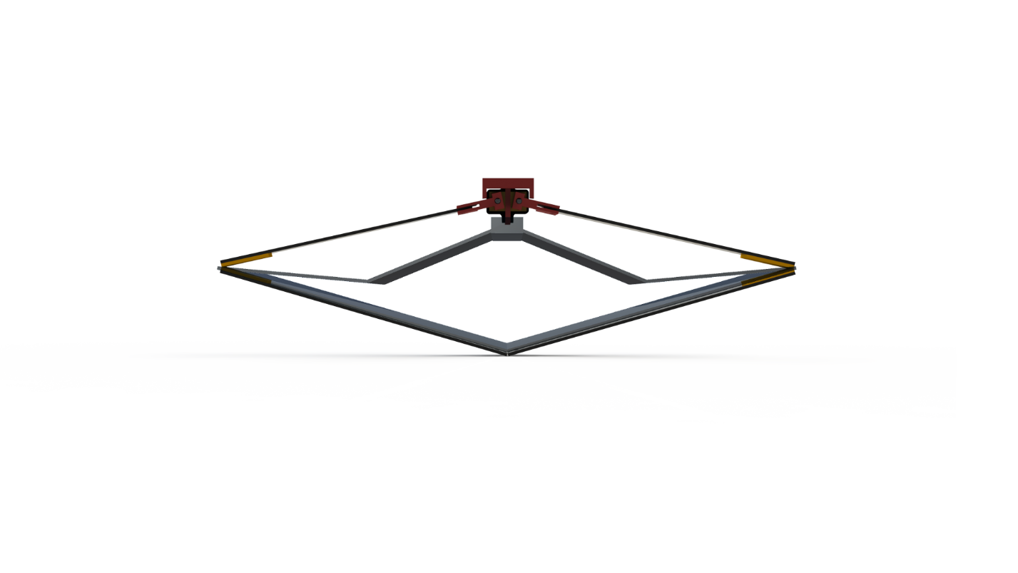

*Figure 1: Unity representation vs physical platform*

Comparing the results between the two simulation methods shows that the single-mass model predicts larger jump heights than the multi-body model for the same leg design. However, both show the same trend of an optimal length/gear ratio combination somewhere in the middle of the design space. A notable difference seen in the figures below is that the multi-body model reaches this maximum with a much shorter leg-length and a comparably faster motor gear ratio than the single-mass model. This is likely because the multibody model includes the added considerations of the increased inertia and decreased stiffness of a longer leg, whereas the single-mass model only considers the increased total weight resulting from a longer leg length. These added considerations favor a faster motor gear ratio and a shorter leg.

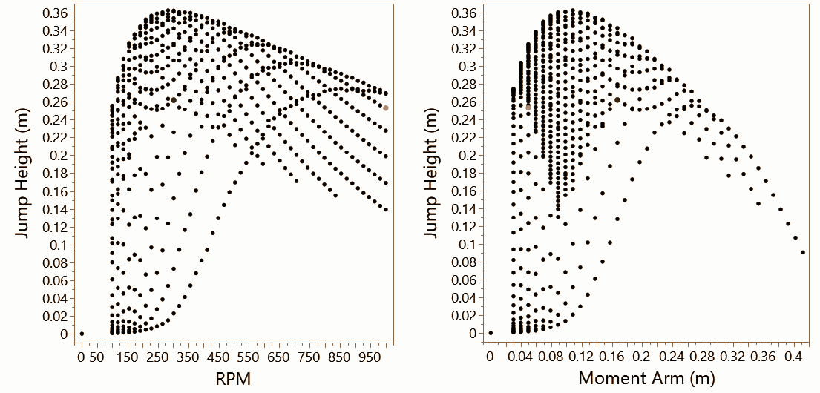

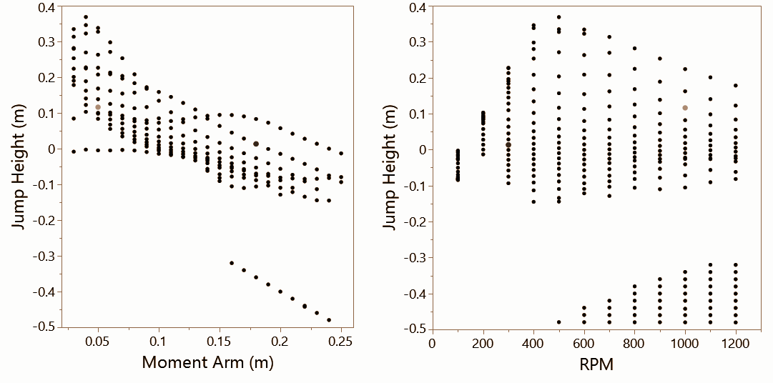

*Figure 2: Single-mass optimization results (top) compared with multi-body Unity optimization results (bottom)*

Experiment

An experimental test setup to record the force produced by the leg, the current through the motors, and the position of the leg was constructed. In each trial, the platform performed a single jump starting from rest on a plate mounted to a load cell collecting force data. As the leg extends, a current sensor and motor encoders record the state of the motors. High speed cameras track the motion of the robot body. The test is performed with several different leg designs chosen utilizing the simulation described above. The figure below shows the representative data collected for the two leg designs. The first uses 18 cm long moment arms and 300 rpm motors, while the second has 5 cm long moment arms and 1000 rpm motors. Both legs utilize laminate fiberglass construction and 3D printed brackets to connect the motors to the laminate device.

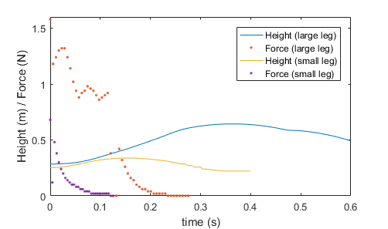

*Figure 3: Representative height and force data for two leg designs*

**Results & Discussion**

Comparing the experimental results with the simulation results shows that both simulations predict a higher jump height than either physical platform is able to achieve. Part of this error is due to the predicted mass of the platform for a given leg length not matching mass of the physical platform exactly. In order to remove this consideration, and assess the validity of the simulation models, the predicted masses used in the optimizations are updated with the measured masses of the legs. These masses are used to create the results shown in the table below, which are compared with the experimental results.

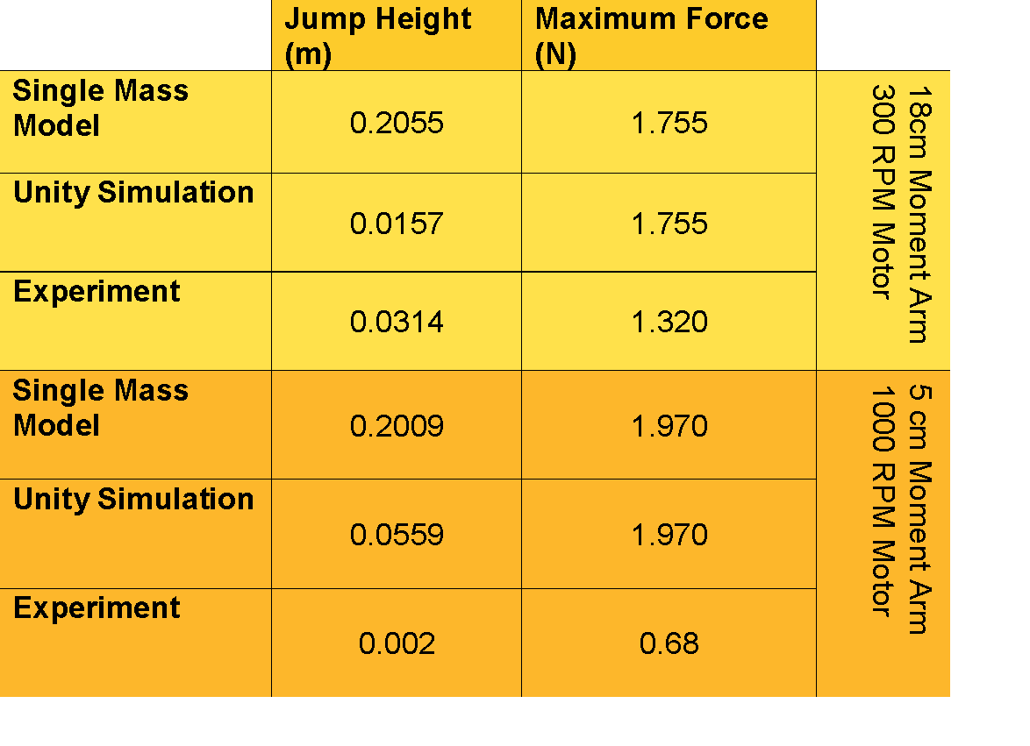

*Figure 4: Simulation results compared with experimental results for two leg designs*

In spite of the measured masses being used in the simulation, even the multi-body simulation does not consistently match the experimental results. Several factors are thought to contribute to this. The first is that the flexibility of the leg members used in the simulation is only an approximation based on results for two different lengths of fiberglass and could be improved by measuring the stiffness of both physical platforms. Another factor is that the inertia of the motor and its gearbox used in the DC platforms is not included in the simulation and may pose a significant factor in hampering the acceleration of the leg.

**Conclusions and Future Work**

The inconsistencies between the experimental and simulation results call for further investigations. An improved experimental setup is needed in order to collect data for a multitude of legs. The improved setup will include current and voltage measurement and will automate the analysis of the collected data. With this additional data, assumptions about the motor performance can be investigated. It may appear that the motor is not performing as expected and this could call for the additional consideration of the motor inertia in the model or it could show that performance information provided by the manufacturer used in the model are incorrect. In either case, the actual motor performance and inertia can be measured and then included in the model. Once discrepancies between experimental and simulation results have been resolved, the final model can be used to select an optimal design for jumping height, and the model can be used in future work to design the legs for a hopping robot.



Mentor Signature: ______________________________________________ Date: _11/14/17_

|  |  |  |
| --- | --- | --- |
| **Purchased/Reimbursed Item** | **Expenses Spent** | **Budget Justification** |
| I2C Current/Voltage Sensor | $9.95 | Measure current and voltage of robot for experiment |
| Analog Current Sensor | $19.90 | Measure current draw of robot during experiment |
| **Total** | **$29.85** |  |